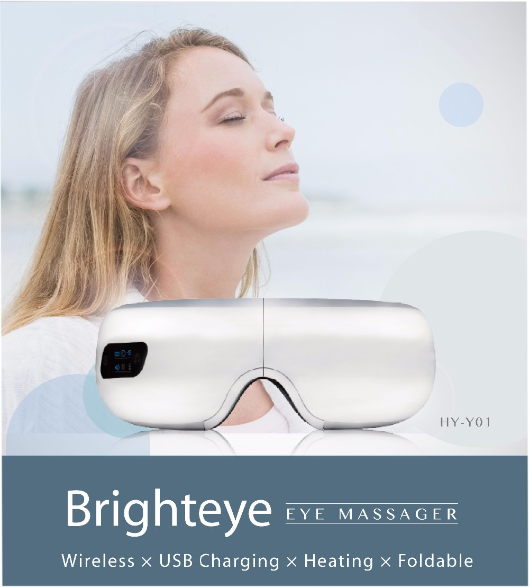

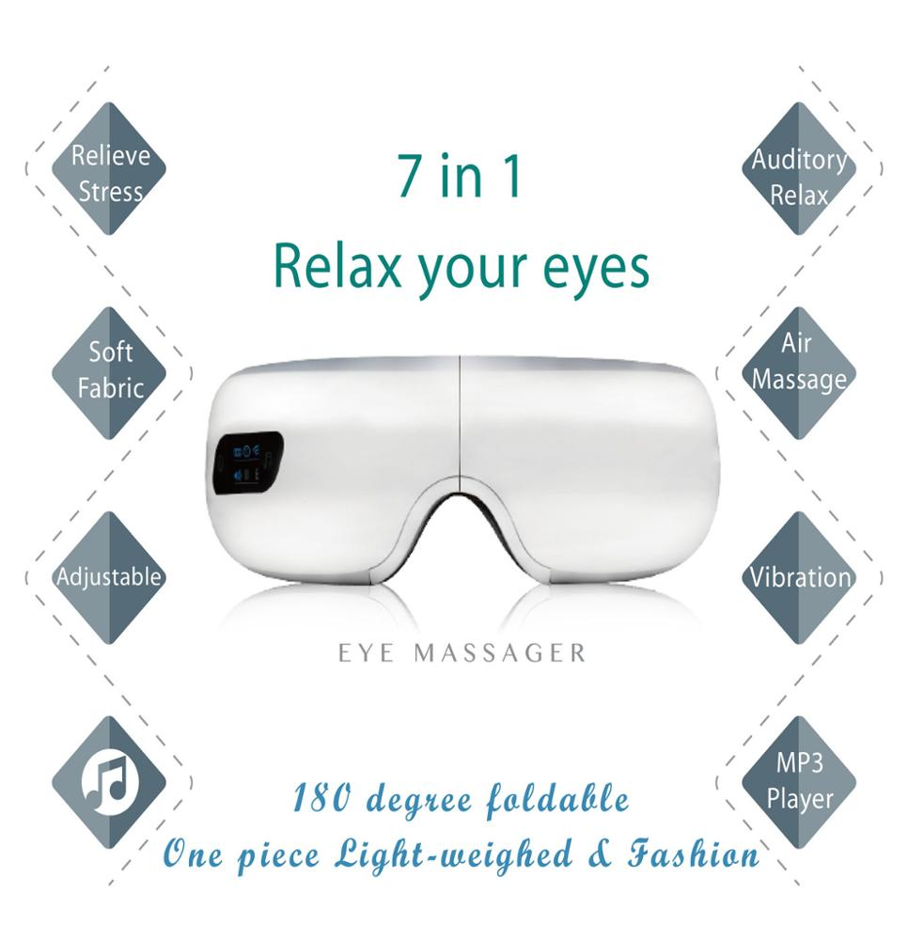

|  |  |  |
| --- | --- | --- |
| **4 in 1 EYE MASSAGER**  **4合1眼部按摩器**    Wireless x USB Charging x Heating x Foldable  无线，USB充电，加热，可折叠 | | |
| **MP3 Playing**    Natural Sound &  Music Download  MP3播放器，可下载音乐 | **Relaxing**    Air Pressure Vibration  Eye Massager  气压震动眼部按摩仪 | **Folding**    Easily Folding Massager  in tiny shape  小巧易折叠 |

|  |  |
| --- | --- |
| Display on Wholesale Electric Folding Heat Vibration Eye Massage Glasses with music | Display on Wholesale Electric Folding Heat Vibration Eye Massage Glasses with music |

|  |  |
| --- | --- |
| Display on Wholesale Electric Folding Heat Vibration Eye Massage Glasses with music | **双边接入高质量音频设备**  **Music & USB Charging**   音乐和USB充电接口    * Built-in Audio Equipment   内置音频设备  * MP3 Music Download and Built-in     Audio equipment  MP3下载及上传音频设备 * Powered by a rechargeable lithium     battery for maximum portability  可充电锂电池，最大限度可携带性 |

|  |  |
| --- | --- |
| Display on Wholesale Electric Folding Heat Vibration Eye Massage Glasses with music | **180 Folding Massager**   180度可折叠    *  Easy to carry 便于携带    *  Folding into a tiny shape and  carry with a travel case  折叠体积小，便于放入旅行箱携带    *  Soft and comfortable materials  to fit your eyes  柔软舒适面料贴合眼睛 |

|  |  |
| --- | --- |
| Display on Wholesale Electric Folding Heat Vibration Eye Massage Glasses with music | **Air Pressure Massage**   空气震动按摩仪    * Three massage modes   三种按摩模式  * Relieves eye strain, dry eyes, sinus     pressure and headaches.   缓解眼部疲劳，眼干，窦压和头痛  * Infrared heating therapy function     to keep 35-45 .C temperature  红外线热疗功能，保持温度在35-45℃ |

|  |  |
| --- | --- |
| Display on Wholesale Electric Folding Heat Vibration Eye Massage Glasses with music | **Eye Massager Design**   眼部按摩仪设计    **\* Clear User Screen** 清晰的用户界面  Simple icons to use easily  简单图标使用方便    **\* Customized**  Company’s logo can be printed on the massager   客户定制  客户LOGO可以印制在按摩仪上  **\* Color** 可选颜色：白色，粉色和金色  样品仅限白色  white, pink, and gold model , sample available in white only |

**Packaging**

|  |  |
| --- | --- |
| **Product name**  **产品名** | Eye massage device / Eye Massager  眼部按摩仪 |
| **Exchange voltage**  **充电电压** | AC 110-240v |
| **Payment terms** | T/T payment |
| **Carton size**  **外箱尺寸** | 52x42x52cm |
| **Rated voltage**  **额定电压** | 5v,50/60hz |
| **Rated power**  **额定功率** | 5w |
| **Eye Massager Size**  **按摩仪尺寸** | 23.5 X 14.5 X 12.8 cm |
| **Eye Massager N.W.**  **净重** | 0.65 kg |
| **Eye Massager G.W.**  **毛重** | 15 kg / carton / 20 pieces |